# 02/14/2019 - Capstone Meeting Notes

**Discussions:**

* 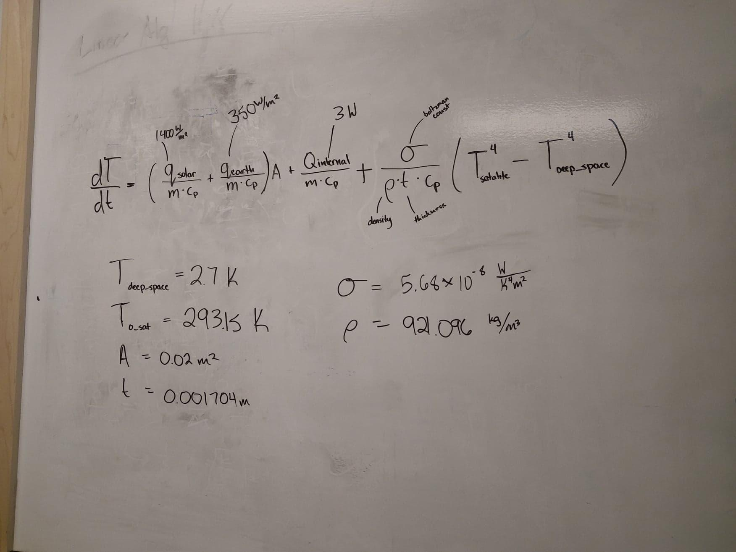

**Progress:**

* Parker
  + Death and decay
* Katherine
  + [IAC paper abstracts due by 02/28](http://www.iafastro.org/wp-content/uploads/2018/11/IAC2019_Call-for-Papers_Update_2018-11-27_FINAL_online.pdf) <- everyone click this link, found out others only work for me (Risto)
  + We have >1.5 months until the [B11 Interim report](https://www.herox.com/spacechallenge/phase/435/entry/create) is due
    - Here are the [requirements docs](https://drive.google.com/open?id=1Gc2Z-gy5zvPNDEApq1RnVANjf6OyD8GG8etcoPRF0MM) (look at ones “Owned” by Kyla Jeffrey
* Tom
* Jeremy
  + Earned edx certificate, mostly through section 4
  + Spoke with gerry about ODE solvers. He’s sending info. Recommended ODE45 function.
  + Also brainstormed more advanced models for ANSYS with Gerry.
* Griffin
  + No progress
  + OreSat Scheduling meeting tomorrow? 4:00-6:00
  + Now that midterms are done we should really get the ODE solved as well as getting more simulations done
  + What is the status on the Vacuum Chamber. We need to come up with a final project for 411
* Tyler
  + No update for this week
  + Agree with Griffin on getting the ODE solved so however I can help with that this week please let me know
  + Katherine covered the Tuesday meeting this week

**Action Items:**

* **Create Ansys Model of ODE to verify results**

**Important notes for Ansys:**

**Important dates:**